1. **Structure analysis.** (Write down the main idea of each paragraph or make a mind-map of the passage structure. The latter is preferred.)

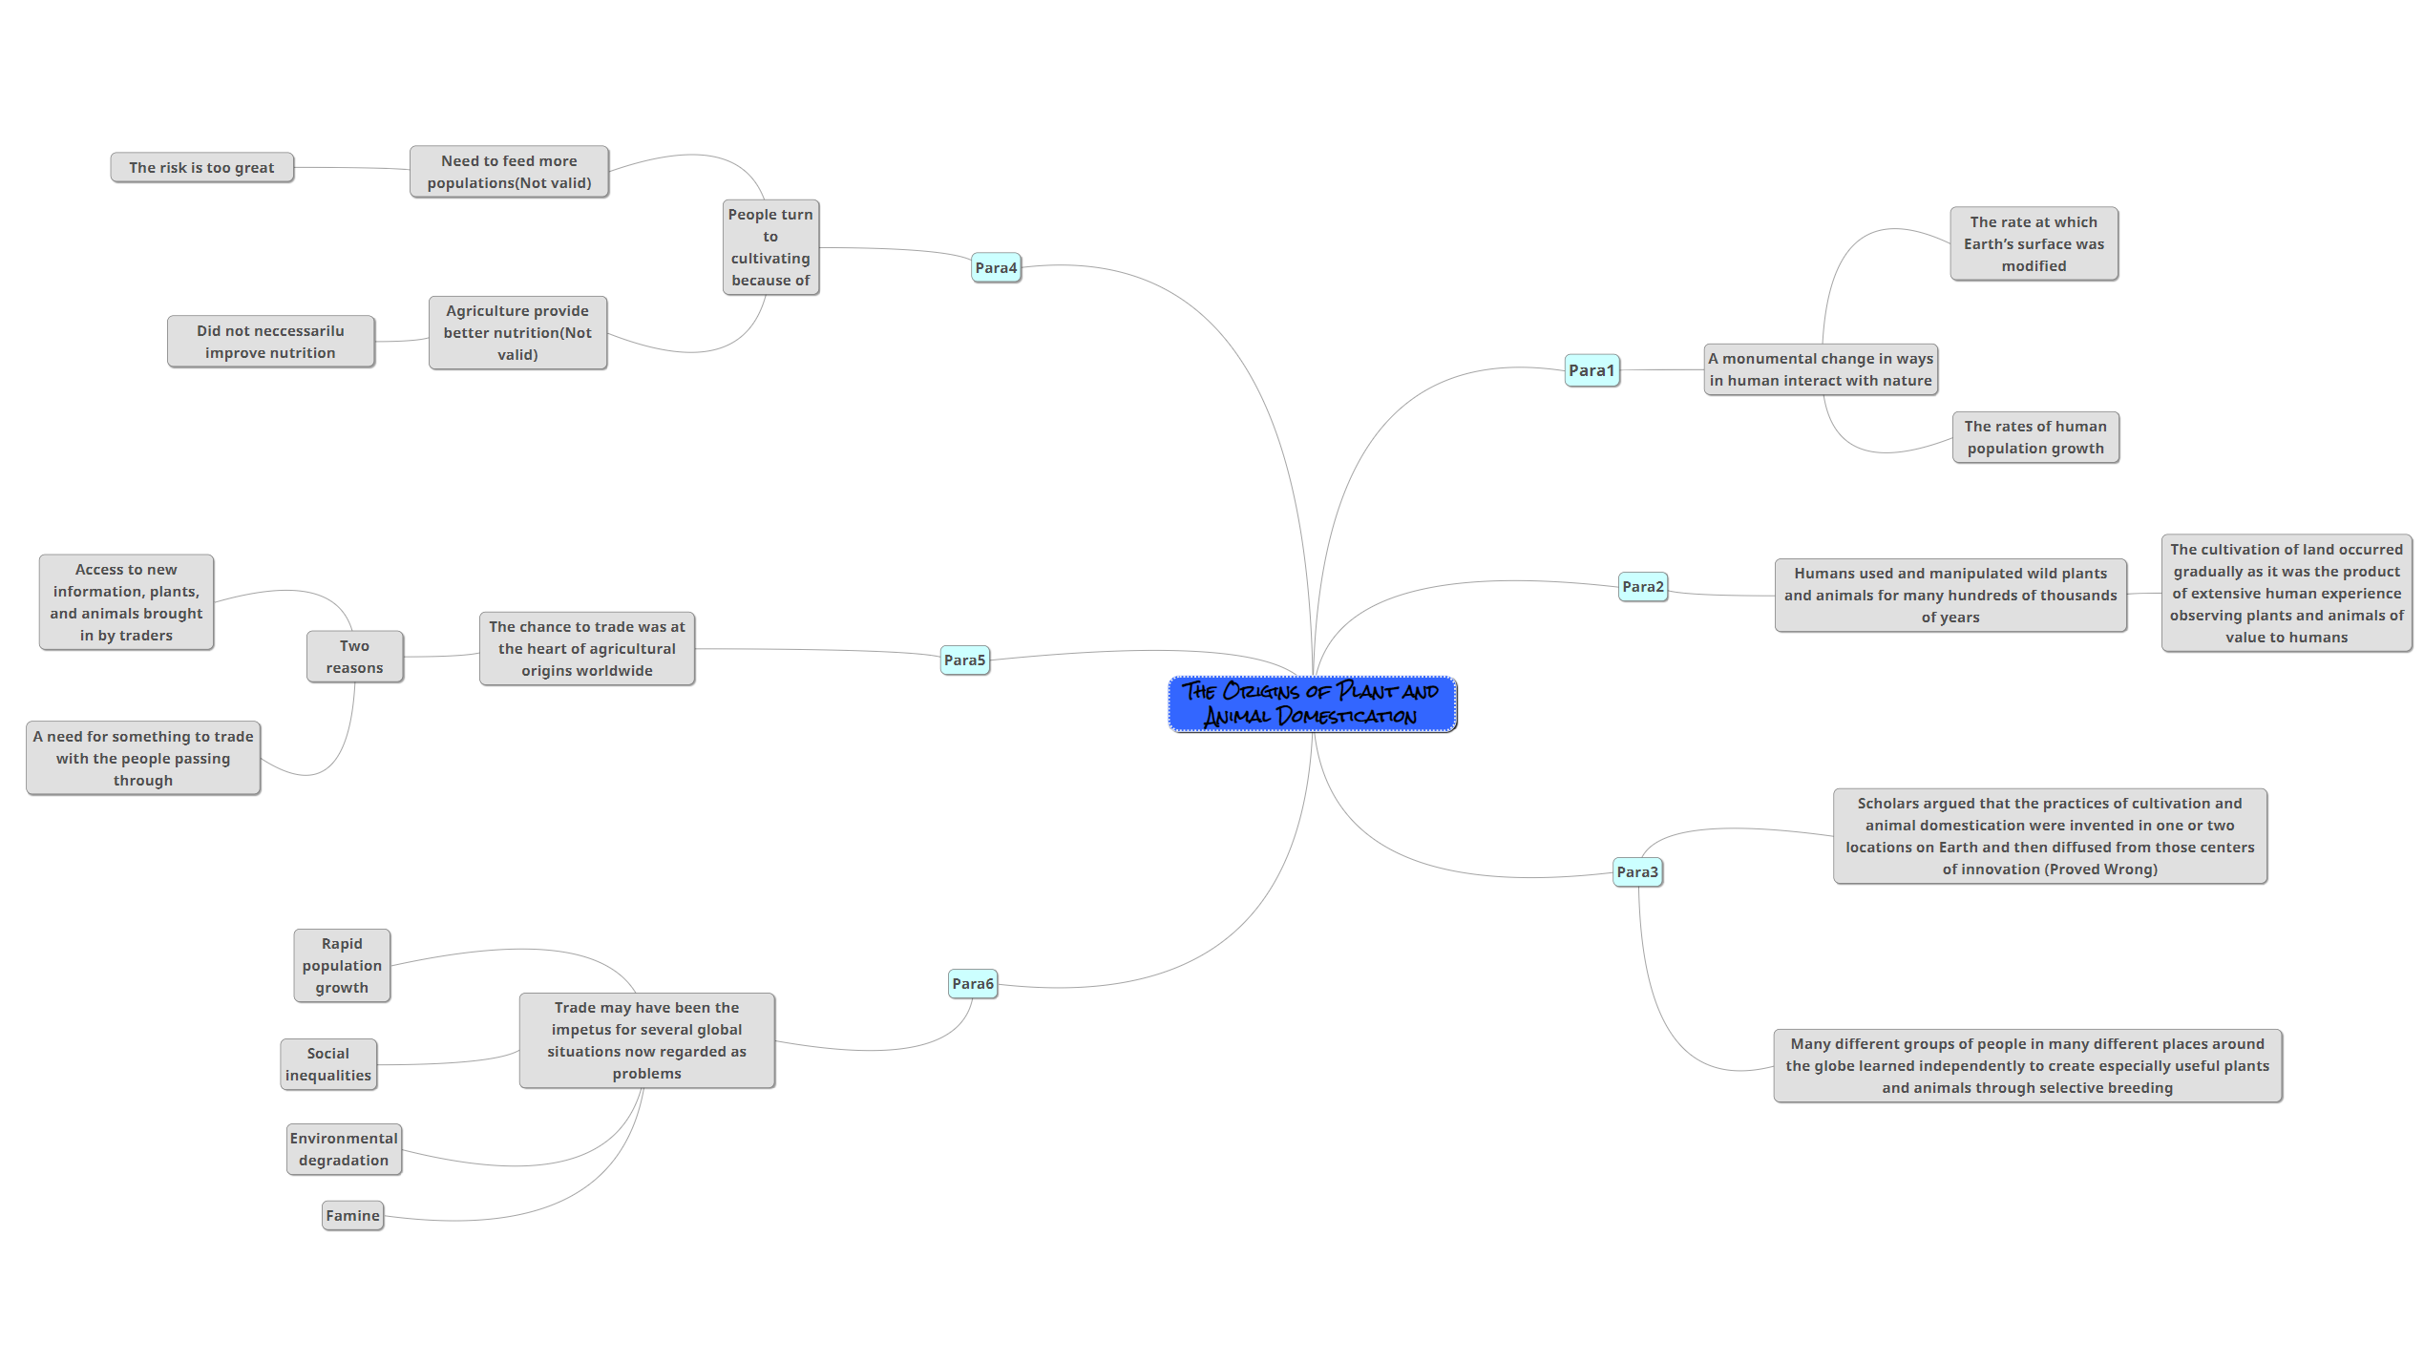

1. **Vocabulary Bank**

|  |  |  |
| --- | --- | --- |
| Domestication 驯化 | Monumental 里程碑似的 | Modify 修改 |
| Disparity 差距 | Hierarchy 阶级 | Cultivate 栽培 |
| Abruptly 突然的 | Pasture 牧场 | Diffuse 扩散 |
| Selective 选择性的 | Breeding 养育 | Relay 中继器 |
| herder 畜牧者 | Burgeoning 蓬勃发展 | Valid 有根据的 |
| nutrient 养分 | Sustenance 粮食 | Impetus 动力 |
| Famine 饥荒 | Drought 干旱 | Solely 仅仅 |

1. **Paraphrase or translate the following sentences by analyze the components.**

1. The transition to gardens, fields, and pastures was probably gradual, the natural outgrowth of a long familiarity with the environmental requirements, growth cycles, and reproductive mechanisms of whatever plants and animals humans liked to eat, ride, or wear.、

向花园，田野和牧场的过渡可能是渐进的，这是人类喜欢吃，骑或穿的任何植物和动物的环境要求，生长周期和繁殖机制的长期熟悉的自然产物。

2. Genetic studies are now showing that many different groups of people in many different places around the globe learned independently to create especially useful plants and animals through selective breeding.

遗传研究现在表明，全球许多不同地方的许多不同群体的人通过选择性育种独立学习创造特别有用的植物和动物

3. Scholars used to assume that people turned to cultivating instead of gathering their food either because they had to in order to feed burgeoning populations, or because agriculture provided such obviously better nutrition.

学者们曾经认为，人们转向耕种而不是收集食物，要么是因为他们不得不养活迅速增长的人口，要么是因为农业提供了明显更好的营养

4. First of all, the risk attached to exploring new food sources when there were already too many mouths to feed would be too great.

首先，当已经有太多的嘴需要投喂时，探索新的食物来源的风险太大了

5. People in such places would have had at least two reasons to pursue cultivation and animal raising; they would have had access to new information, plants, and animals brought in by traders, and they would have had a need for something to trade with the people passing through.

在这样的地方，人们至少有两个理由去耕种和养育动物;他们本来可以获得贸易商带来的新信息，植物和动物，他们需要一些东西来与路过的人进行交易

**5. Make a summary of the passage within 150 words.**

The passage talks about the origins of plant and animal domestication. The writer claims that